

Credit Reliability Assessment for Rural India using Machine Learning

(SYNOPSIS)

Submitted to the
Department of Master of Computer Applications
in partial fulfillment of the requirements
for the Mini Project (MCAP1)

by

Vilas K N

1MS22MC055

Under the guidance of

Dr Monica R Mundada

Department of Master of Computer Applications
RAMAIAH INSTITUTE OF TECHNOLOGY
(Autonomous Institute, Affiliated to VTU)
Accredited by National Board of Accreditation & NAAC with ‘A+’ Grade
MSR Nagar, MSRIT Post, Bangalore-560054
www.msrit.edu
2023

- Project Overview

  - Introduction

In this Banking Industry loan approval is done based on the thorough assessment of a customer repayment capability. Credit score plays a major role in this assessment which reveals the credibility of a person. However, rural individuals in India often lack a credit score, making it challenging to evaluate repayment capabilities directly.
In the absence of traditional credit score in rural India , this project aims to develop a machine learning model capable of assessing creditworthiness.
The hypothesis is that a comprehensive analysis of personal, financial , historical loan details and other factors like Land, house, average income and other assets can provide valuable insights which help to determine maximum repayment capability and facilitate more accurate lending decisions.

1.2 Objectives

- Understand the economic factors that affect how reliable someone is for credit in rural India .
- Find important signs that help judge if someone can be trusted to repay a loan,especially when they don't have a regular credit history.
- Build a computer program that can predict if someone is likely to repay a loan, using both regular and new kinds of information
- Make a tool that's easy for banks to use, helping them decide if someone is a good fit for a loan based on our predictions.

1.3 Scope

- Target audience : Financial institutions, lenders, and credit agencies
- Platforms supported : Initially designed as a web application, with potential expansion to mobile platforms in future phases.

1.4 Features

- Customized Predictive Credit model: A customized credit assessment model designed specifically for rural demographics, predicting creditworthiness with precision.
- Seamless Integration with Financial Workflows: An intuitive and user-friendly interface seamlessly integrated into financial processes, ensuring a smooth experience for users and institutions alike.
- Comprehensive Credit Evaluation: Incorporation of a wide array of both conventional and unconventional factors to provide an all-encompassing evaluation of credit, capturing a holistic view of an individual's financial reliability.

- Project Architecture

2.1 System Components

- Frontend: User interface for interacting with the system.
- Backend: Core logic for credit assessment and data processing.
- Database: Storage of relevant data for model training and application usage. Technologies Used

2.2 Technologies used

- Programming Language: Python , Flask(web)
- Platform : Google colab
- Framework: Scikit-learn (Python)

  - Model :

The machine learning model used for this project is based on the comparative analysis of existing models like Linear Regression, Random Forest and Decision Tree.
Mean Absolute Error (MAE), Mean Squared Error (MSE) and Root Mean Squared Error (RMSE) will be the metrics used to evaluate the performance of the predictive model.

  - Data Flow Diagram:
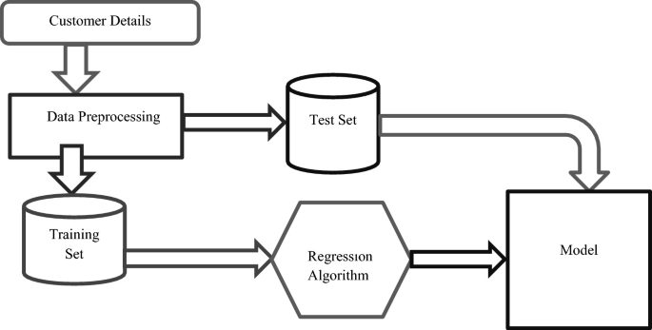

- Functionalities:

- Data Input Module: Facilitates the input of individual socio-economic data.
- Credit Assessment Module: Utilizes machine learning model for predicting credit reliability.
- Results Display Module: Presents the assessment results to the user and financial institutions.
- Reporting Module: Generates comprehensive reports for record-keeping and analysis.

